**ROBOTIC CONTROL SYSTEM BASED ON OBJECT DETECTION & ACCIDENTAL ALERT SYSTEM**

**Prof. A.S Utane*1 , Ritesh Hande *2, Pranav Kale*3, Prathmesh Joshi*4 , Arjun Mishra *5**

*1Assistant Professor, Department Of Electronics & Telecommunication Engineering, Prof. Ram Meghe Institute Of Technology & Research, Amravati, Maharashtra.

*2Students, B.E, Electronics & Telecommunication Engineering, Prof. Ram Meghe Institute Of Technology & Research, Amravati, Maharashtra.

**ABSTRACT**

The integration of robotic control systems with advanced object detection and Accidental alert mechanisms represents a significant advancement in the realm of robotics and automation. This project focuses on developing a sophisticated robotic control system that leverages cutting-edge object detection algorithms to enhance the robot's environmental awareness and safety. Utilizing computer vision techniques, the system enables the robot to identify and localize various objects in its vicinity, facilitating intelligent navigation and interaction in dynamic environments.

In addition to object detection, the proposed system incorporates a robust Accidental alert system designed to preemptively identify potential collision risks. By continuously monitoring the robot's surroundings and analyzing real-time data, the Accidental alert system can promptly detect obstacles or hazards, triggering immediate corrective actions to avoid collisions and ensure the robot's safe operation.

Furthermore, the project explores the implementation of a user-friendly interface to facilitate easy configuration and customization of the robotic control parameters, enabling operators to adapt the system to specific application requirements effectively. The proposed robotic control system offers promising potential for a wide range of applications, including industrial automation, autonomous vehicles, and service robots, paving the way for safer and more intelligent robotic systems in various domains.

**Keywords:** Accidental Alert System, Arduino Nano, Driver Safety, Object Detection.

1. **INTRODUCTION**

In recent years, the integration of robotics and automation technologies has revolutionized various industries, ranging from manufacturing and logistics to healthcare and entertainment. As robotic systems become increasingly prevalent in our daily lives, there is a growing demand for advanced control mechanisms that can enhance their capabilities, safety, and efficiency. One of the critical challenges in developing intelligent robotic systems lies in enabling them to interact seamlessly with their environment, adapt to dynamic changes, and avoid potential hazards autonomously.

Object detection and collision avoidance are fundamental aspects that significantly influence the performance and safety of robotic systems operating in complex and unstructured environments. Traditional robotic control methods often rely on predefined paths or manual intervention, limiting their adaptability and responsiveness to unexpected situations. With the advent of sophisticated sensor technologies and machine learning algorithms, there is an opportunity to develop more intelligent and proactive robotic control systems capable of real-time object recognition and collision prediction.

The primary objective of this project is to design and implement a robotic control system that leverages advanced object detection techniques and Accidental alert mechanisms to enhance the robot's navigation and safety capabilities.

By integrating state-of-the-art computer vision algorithms, the system aims to provide the robot with the ability to identify and localize various objects, such as obstacles, pedestrians, and other vehicles, in its surrounding environment.

This enhanced environmental awareness will enable the robot to make informed decisions and navigate complex terrains more effectively, reducing the risk of collisions and enhancing operational efficiency.

By continuously monitoring the robot's surroundings and analyzing real-time sensor data, the Accidental alert system will provide an additional layer of safety, ensuring the robot's safe operation in dynamic and unpredictable environments.

By continuously monitoring the robot's surroundings and analyzing real-time sensor data, the Accidental alert system will provide an additional layer of safety, ensuring the robot's safe operation in dynamic and unpredictable environments.

1. **METHODOLOGY**

The proposed robotic control system integrates advanced object detection and Accidental alert technologies to enhance the capabilities and safety of robotic platforms in various applications. Utilizing state-of-the-art computer vision algorithms, the system enables the robot to perceive and understand its environment effectively, identifying obstacles, landmarks, and other relevant entities through onboard cameras and sensors.

Object detection enhances the robot's situational awareness, enabling intelligent navigation and interaction in dynamic environments. The system's robust Accidental alert mechanism preemptively identifies potential collision risks, utilizing real-time sensor data and predictive analytics to trigger immediate corrective actions, ensuring safe operation and minimizing accident risks.

Designed with modularity and scalability in mind, the control architecture facilitates seamless integration with diverse robotic platforms and configurations. Leveraging sensor fusion techniques, machine learning algorithms, and adaptive control strategies, the system adapts to different operating conditions and application requirements, allowing operators to customize control parameters and optimize performance.

**Block Diagrams -**

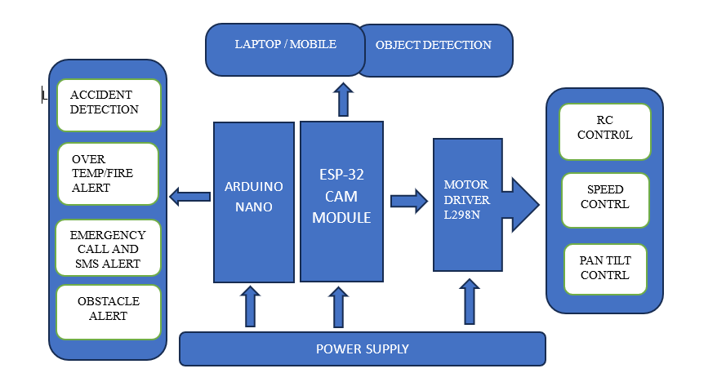

**Figure 1 : System Block Diagram**

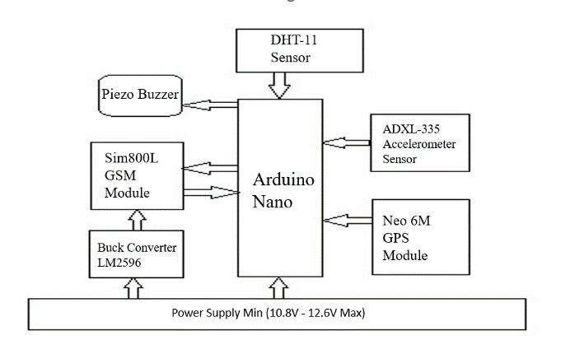

**Figure 2 :** Accidental Alert System

1. **IMPLEMENTATION**

**Circuit Diagram –**

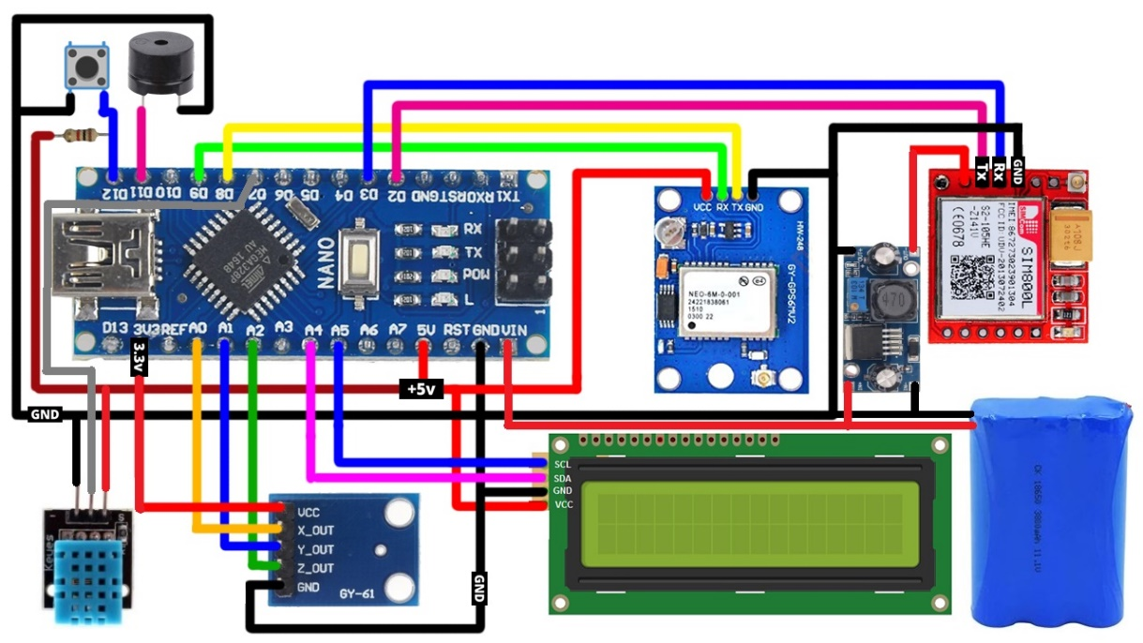

**Figure 3:** Circuit Diagram of Accidental Alert System.

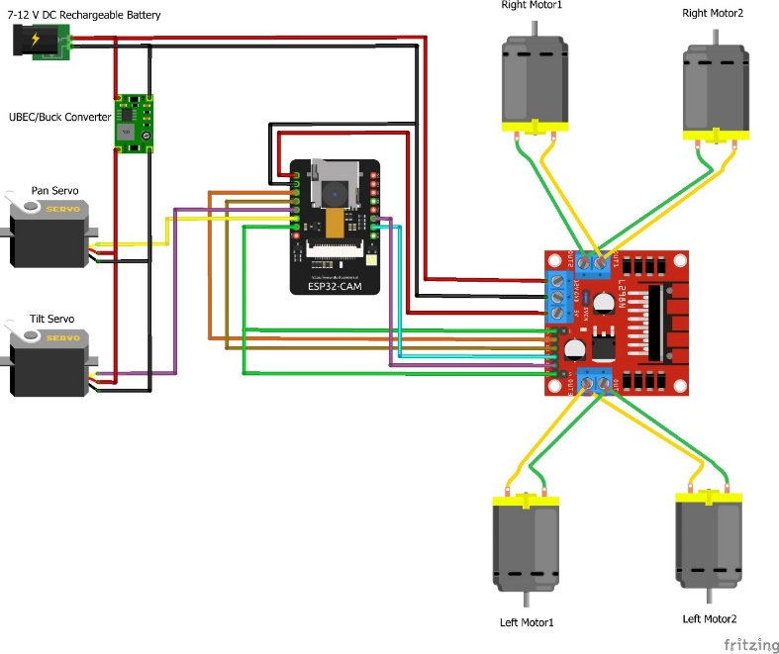

**Figure 4:** Pan – Tilt **C**ircuit Diagram

**Experimental Setup –**

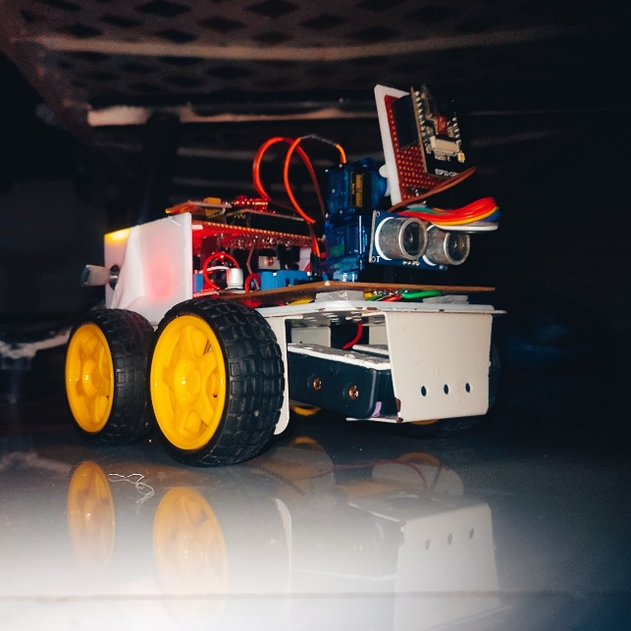 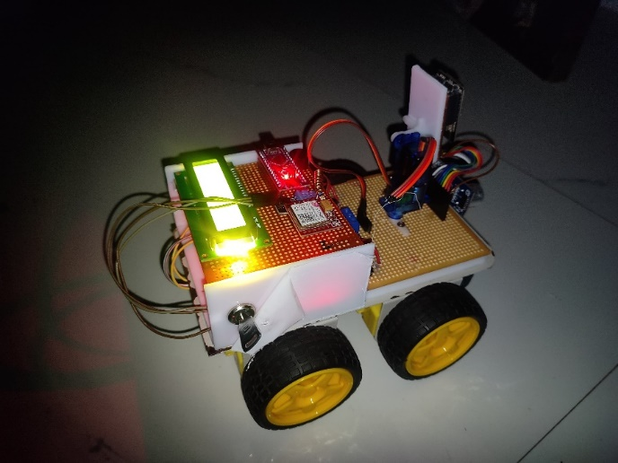

**Figure 5:** Front & Top View OfRobotic Control System

**Hardware Required –**

1. Arduino Nano

2. SIM 800L

3. Neo 6m GPS Module

4. L298N Motor Driver

5. ESP32 CAM

6. Gear Motor

7. 18650 Battery

8. Servo Motor

9. LM2596 Buck Converter

10. I2C LCD

**Software Required –**

Arduino IDE

1. **RESULTS AND OUTPUT**

We have utilized the ESP32 CAM with the L298N motor driver for monitoring and controlling the bot. This allows for controlling its speed, Headlight brightness, and the camera's pan-tilt position via the IP address generated by the ESP32 CAM on a web server, providing a better user interface. Additionally, we have integrated object detection into the web server for enhanced functionality.

To further enhance the bot's capabilities, we have incorporated an Arduino Nano and an ultrasonic sensor. This setup notifies the user with a beep when the bot approaches an obstacle. Furthermore, we have integrated a SIM800L and a 6M GPS module to provide call and SMS alerts in case of accidental behavior by the bot. These alerts are triggered by sensors such as the ADXL335 accelerometer for Accidental detection and the DHT11 sensor for monitoring high temperature and humidity, which helps in detecting fire and other emergencies, ensuring the safety and improved performance of the bot.

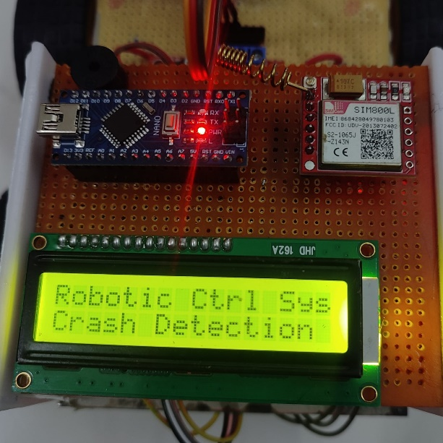 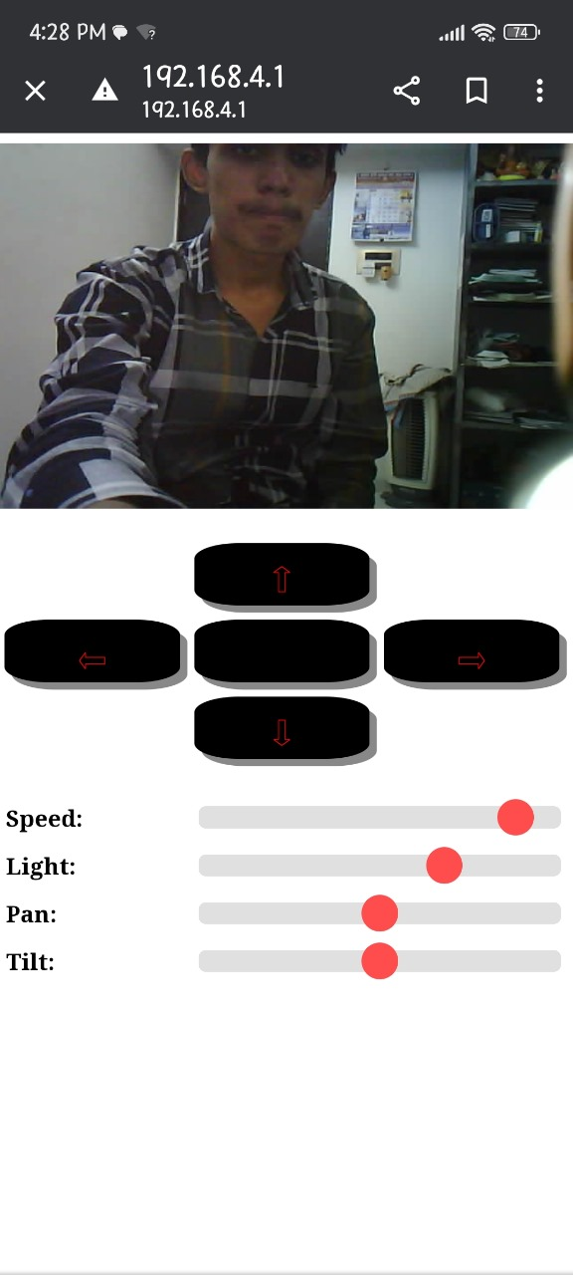

**Figure 5:** Accidental Detection **Figure 6:** Pan-Tilt Web Page

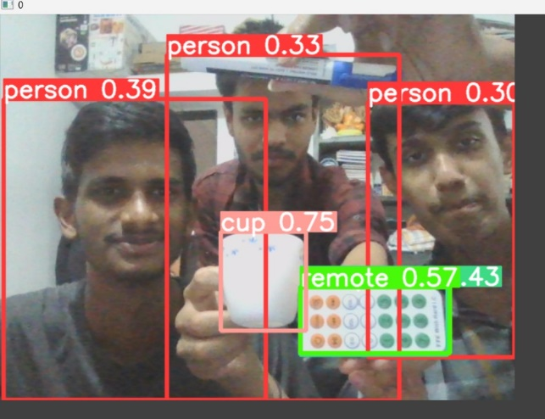

**Figure 7:** Object Detection

1. **CONCLUSION**

The proposed robotic control system leverages advanced object detection and Accidental alert technologies to enhance the navigation, safety, and efficiency of robotic platforms across diverse applications. Integrating state-of-the-art computer vision algorithms, the system enables robots to perceive and understand their environment, identify obstacles, and interact intelligently in dynamic settings.

With a robust Accidental alert mechanism, the system preemptively detects potential collision risks, triggering immediate corrective actions to ensure safe operation and minimize accident risks. Designed for modularity, scalability, and adaptability, the control architecture facilitates seamless integration with different robotic platforms, allowing operators to customize control parameters and optimize performance.

Additionally, an intuitive user interface provides operators with real-time feedback and visualization tools for easy configuration and monitoring, ensuring smooth and efficient robotic operation.

1. **REFERENCES**

[1] S., Mohanapriya & P., Natesan & P., Indhumathi & P., Mohanapriya & R., Monisha. (2021). Object and lane

detection for autonomous vehicle using YOLO V3 algorithm. AIP Conference Proceedings. 2387. 140009.

10.1063/5.0068836.

[2] A., Shaikh & Kureshi, Dr. (2020). Object Detection and Tracking using YOLO v3 Framework for Increased

Resolution Video. International Journal of Innovative Technology and Exploring Engineering. 9. 118-125.

10.35940/ijitee.E3038.049620.

[3] Panthati, Jagadeesh. (2022). Traffic Object Detection and Distance Estimation Using YOLOv3.

10.4271/2022-28-0120.

[4] Givan, Daxton & Hanshaw, Noah & Choi, Heejun. (2022). Application of Lane Navigation and Object

Detection in a Deep-Learning Self-driving Car. 10.1007/978-3-030-98012-2_63.

[5] Lim, Yuxiang & Tiang, Sew & Lim, Wei Hong & Wong, Chin Hong & Mastaneh, Mokayef & Chong, K. & Sun,

Bo. (2024). Object Detection in Autonomous Vehicles: A Performance Analysis. 10.1007/978-981-99-

8498-5_21.

[6] Wang, Rui & Wang, Ziyue & Xu, Zhengwei & Wang, Chi & Liu, Qiang & Zhang, Yuxin. (2021). A Real-time

Object Detector for Autonomous Vehicles Based on YOLOv4. Computational Intelligence and

Neuroscience. 2021. 10.1155/2021/9218137.

[7] Monteadora Renzo (2022).Ros Based Self-Driving Rc Car with Tensorrt Integration In Reducing

Behavioral Cloning Latency And Object Detection For Collosion Prevention.

10.13140/RG.2.2.15364.60803..

[8] Hallan, Akul & Rawat, Shreya & Kumar, Sandeep & Ul-Haq, Ahsan & Gandhar, Abhishek. (2020). Vehicle

Accidental Alert System. 24-30.

[9] Karuna, Gotlur & Kumar, Ram & Sai, Vadlapatla & Abhishek, Jula & Shashikanth, Mood & Kashyap, Burra.

(2023). Motorcycle Accidental Detection and Alert System using IoT. E3S Web of Conferences. 391.

10.1051/e3sconf/202339101145.